

Name: VANSH GUPTA

Object Oriented Programming (OOP) Laboratory File

Sap ID: 500123239
Enrollment No: R2142230209
Batch: B4

Experiment 5 Inheritance & Polymorphism

1. Accessing Private Members in Inheritance
Write a Java program to demonstrate that a private member of a superclass cannot be accessed directly from a derived class.

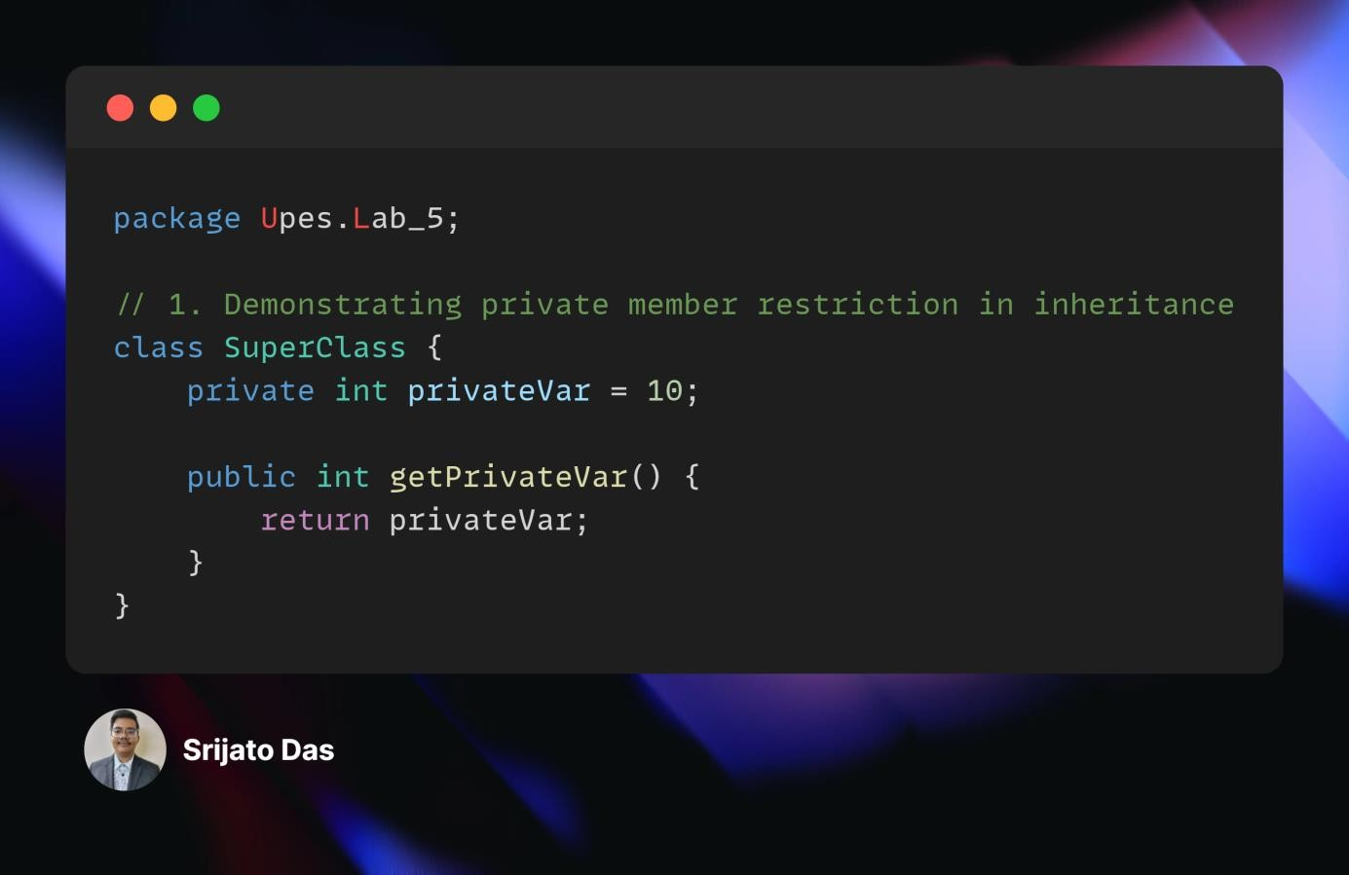

2. Employee & Manager Class (Inheritance and Method Overriding)
Design a Java class Employee with the following features:
- Attributes: name, empid, salary • Constructors:
  - Default constructor o Parameterized constructor
- Methods:
  - Return the employee’s name and salary
  - increaseSalary(double percentage) → increases the salary by a userspecified percentage
Create a subclass Manager that extends Employee and includes:
- An additional instance variable: department
Objective:
- Develop a test program to validate these functionalities.

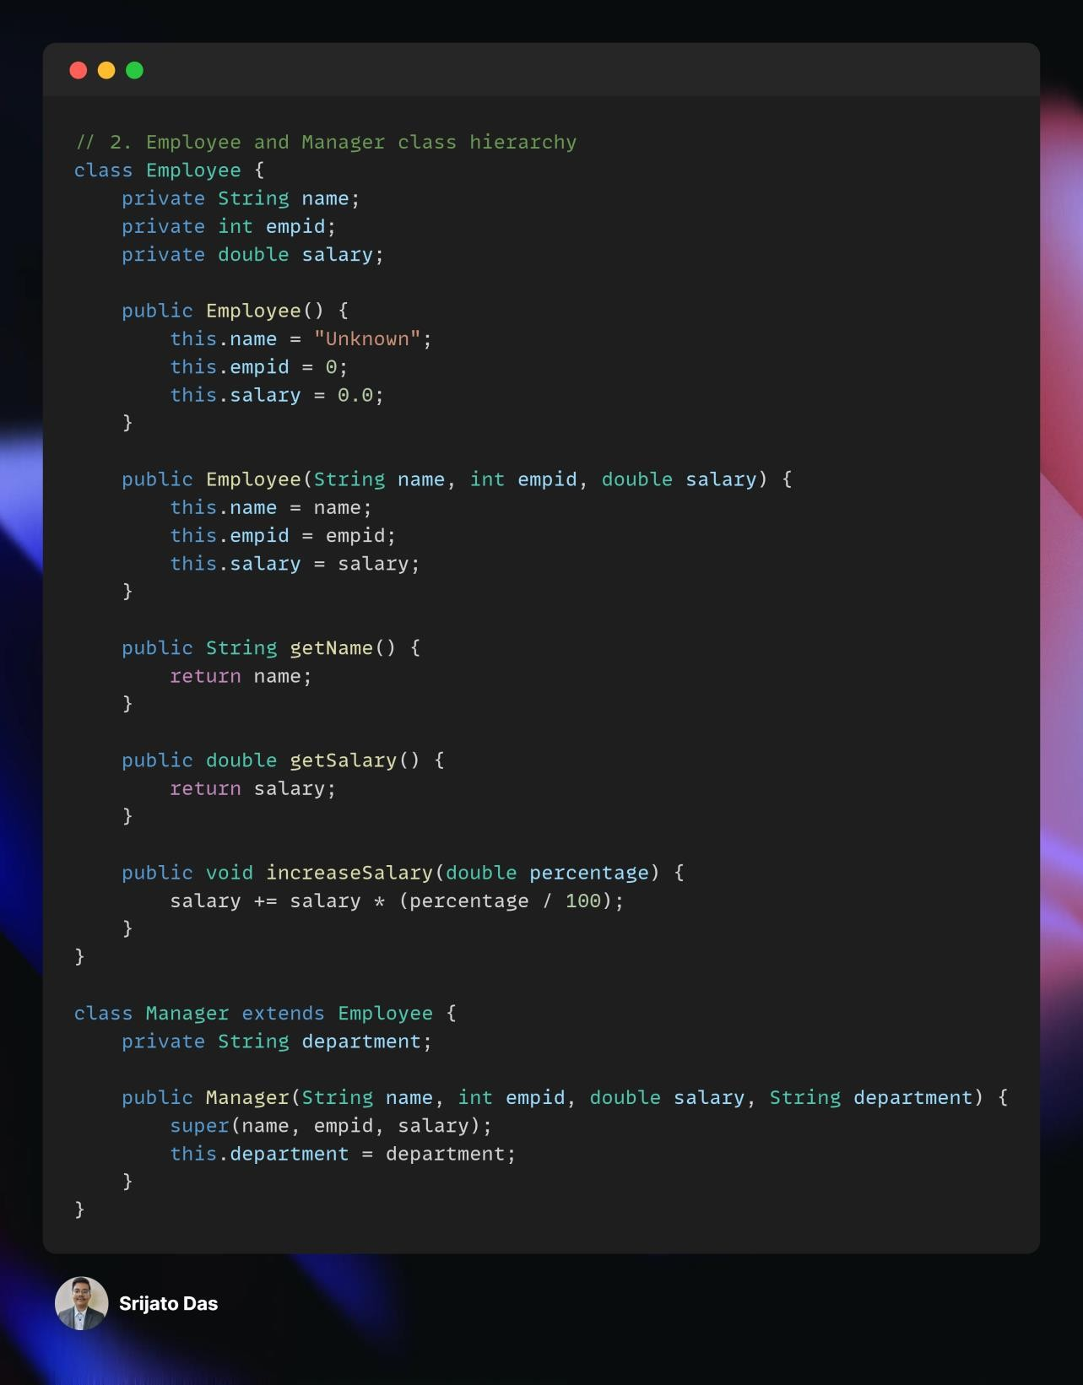

3. University Management System (Multilevel Inheritance & Method Overriding)
A university has different types of people associated with it:
- Base Class: Person → Common attributes: name, age, address
- Subclass: Staff → Adds attributes: staffId, department
- Subclass: Professor (Extends Staff) → Adds specialization and method conductLecture()
- Subclass: Student (Extends Person) → Adds studentId, course
- Subclass: GraduateStudent (Extends Student) → Adds researchTopic and method submitThesis()
Objective:
- Implement multilevel inheritance and method overriding.
- Demonstrate polymorphism by creating an array of Person objects containing instances of Professor and GraduateStudent, then calling their respective methods.

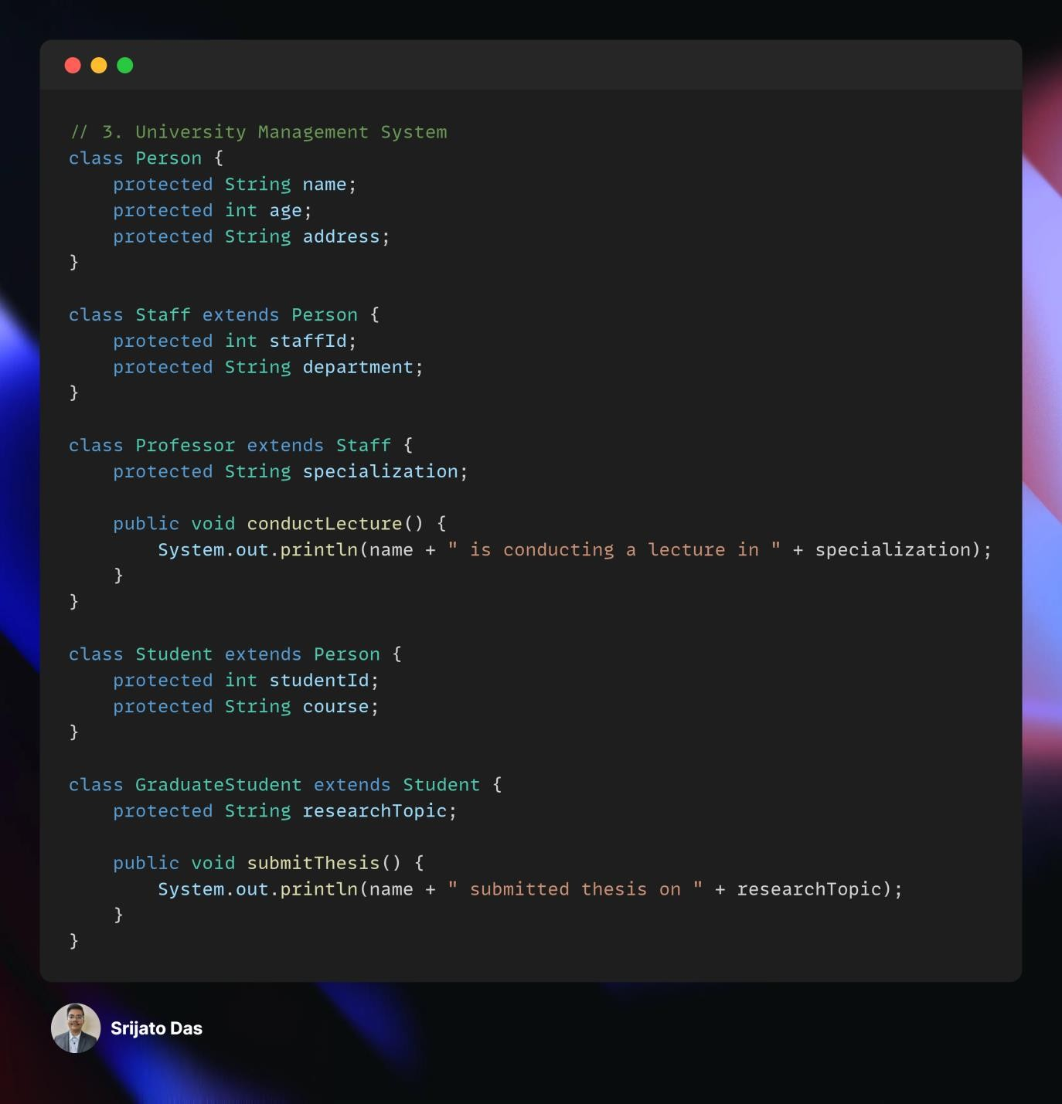

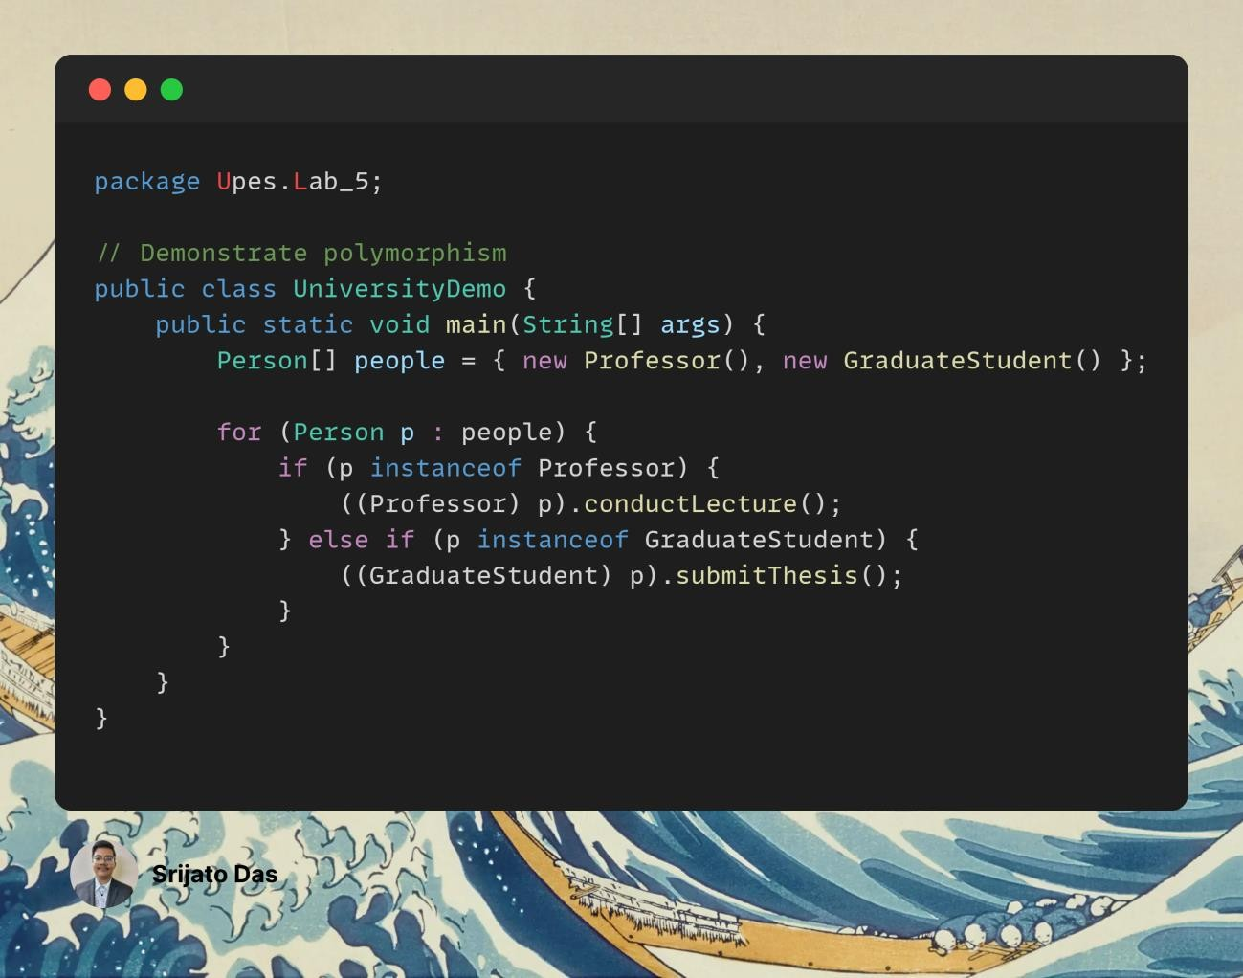

4. Abstract Class Vehicle & Concrete Car Class
Design an abstract class Vehicle with:
- Abstract methods: o startEngine() o stopEngine()
- Non-abstract method:
  - serviceInfo() → Prints basic servicing instructions
- Attributes (protected/private):
  - make, model
- Constructor to initialize make and model
Create a concrete class Car that extends Vehicle and provides implementations for:
- startEngine() → Simulates starting a car engine
- stopEngine() → Simulates stopping a car engine
Objective:
- Instantiate a Car object in main(), call all available methods, and verify that abstraction works correctly.

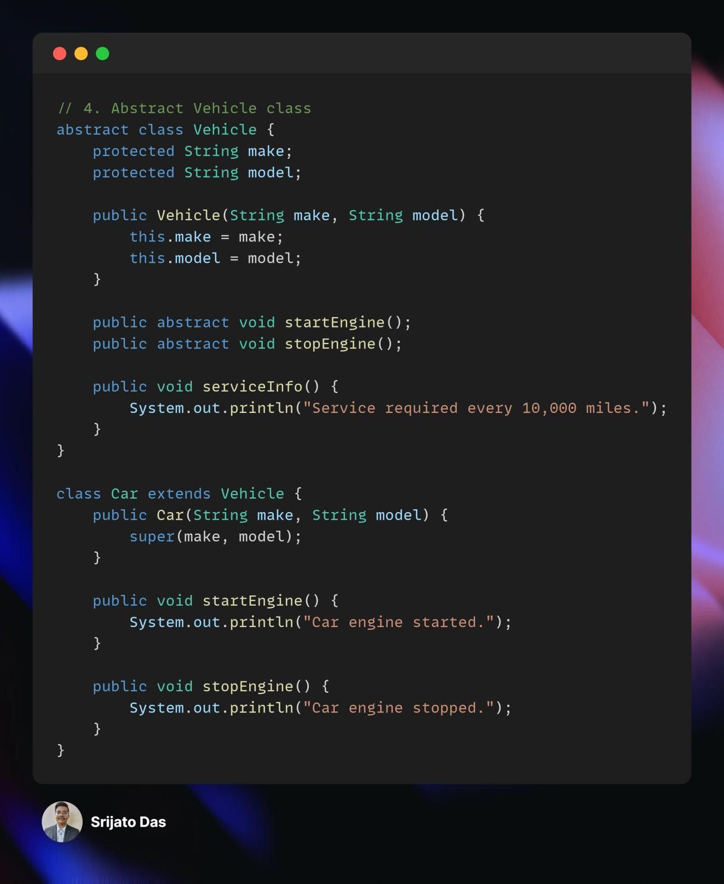

5. Restaurant Management System (Polymorphism & Method Overriding)
Imagine designing a restaurant management system with a base class:
- Base Class: Chef o Method makeSpecialDish() → Prints a generic message (e.g.,
"Making a special dish")
- Subclasses: ItalianChef, ChineseChef, MexicanChef o Override makeSpecialDish() with: ▪ "Making pasta" (ItalianChef)
  - "Making dumplings" (ChineseChef)
  - "Making tacos" (MexicanChef)
Objective:
- Declare an array/list of Chef references, but assign each element to a different subclass (ItalianChef, ChineseChef, MexicanChef).
- Use a loop to call makeSpecialDish() on each element.
- Observe how runtime polymorphism ensures that the correct subclass version of makeSpecialDish() is invoked.

